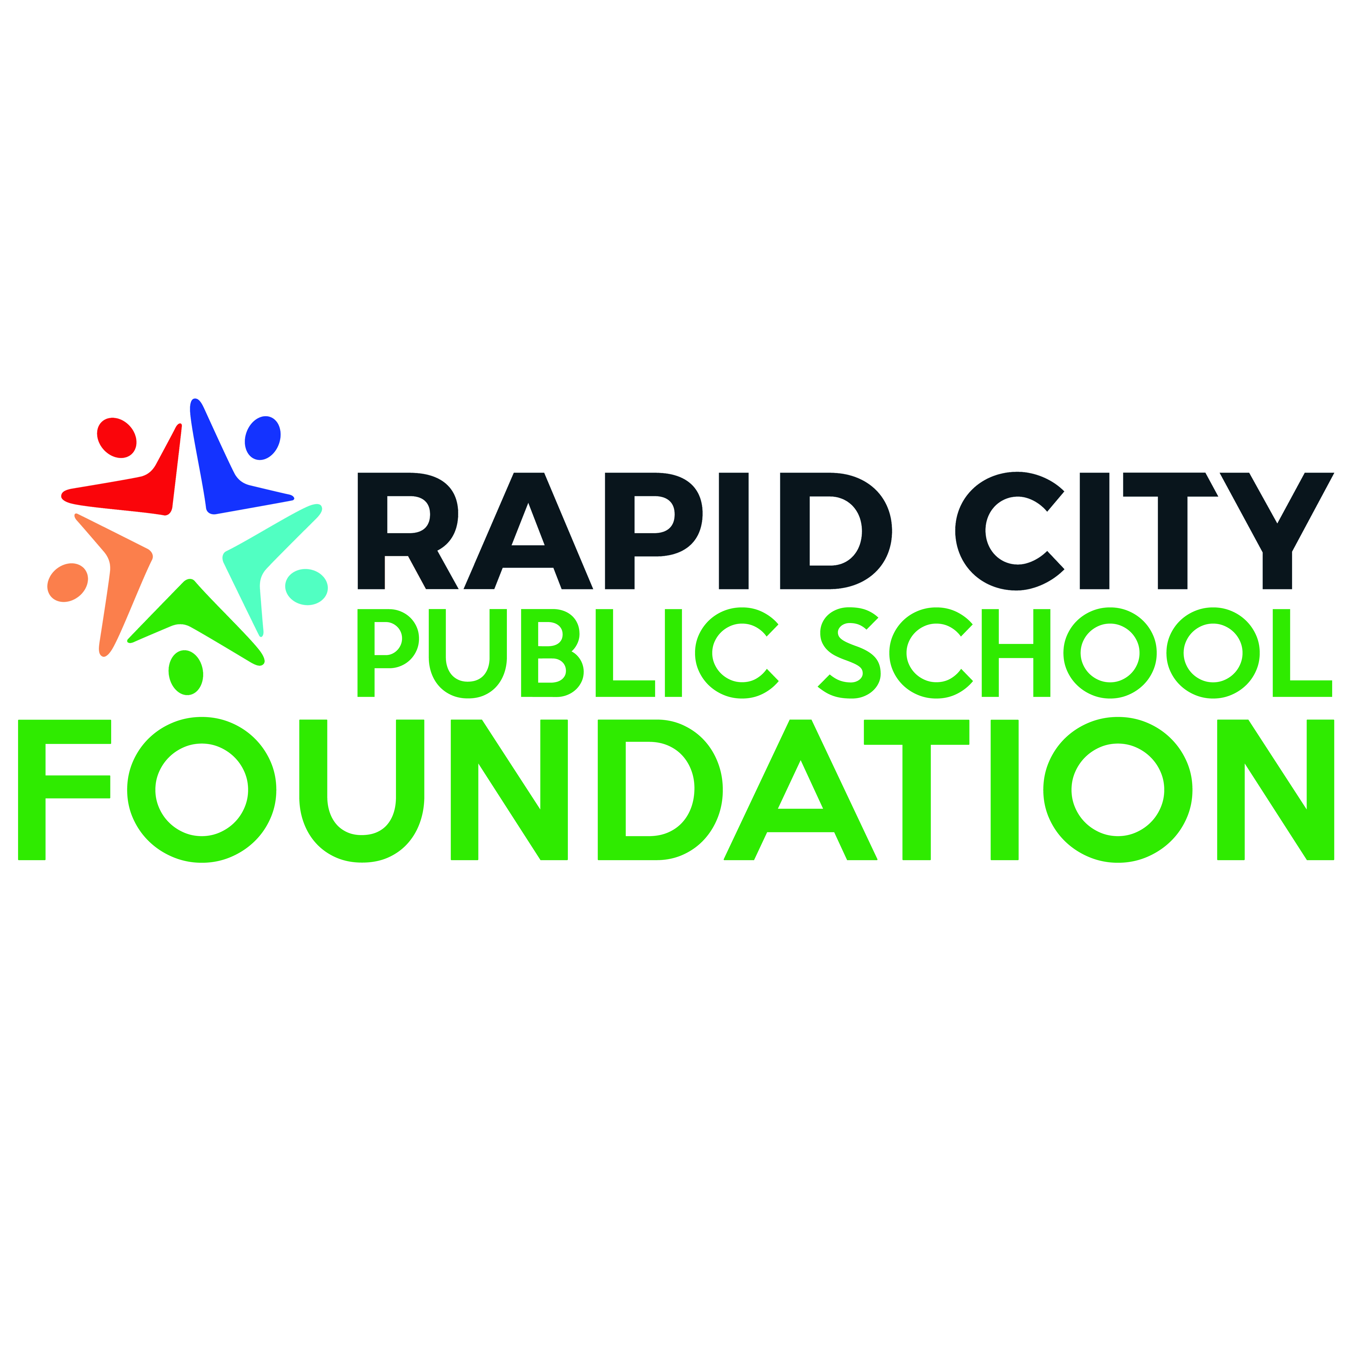

**GRANT PROGRAM – Guidelines and Application**

Each year the Rapid City Public School Foundation fundraises to support our grants program. The foundation seeks to provide monetary support for RCAS staff and students to develop new programs through educational partnerships and innovative solutions.

**We will be reviewing applications in September, October, November, January, February, March and April. April is the last month we will accept donations due to the fact the funds HAVE to be spent before the end of May.** Applications will be due the first week of the month. If you have any questions about the application or the process, please contact Sara Hornick ([Sara.Hornick@k12.sd.us](mailto:Sara.Hornick@k12.sd.us))

Will your grant require, any of the following:

* IT (will your grant require purchasing of any technology or installation of technology)

Any questions and for IT approval contact, shane.daniels@k12.sd.us

* Buildings/Grounds/Maintenance (will your grant require any structural, electrical or plumbing support for installation)

Any questions and for department approval contact, jade.clement@k12.sd.us

* Business Office ( will your grant require RFPs)

Any question and for department approval, contact [coy.sasse@k12.sd.us](mailto:coy.sasse@k12.sd.us)

* My grant request will require, none of the above.

**GRANT TYPES:**

* Small Grants: Grant limit is $2000.
* Grant used to support innovative and creative classroom projects that could be duplicated in other classrooms.
* Grant should only be requested for projects that are not eligible for funding through RCAS budget.
* Application may be made by an individual staff member.
* Approval review must be given by school principal
* Examples of past grants include purchase of software for digital dissection in biology, beekeeping program, Lego solar system simulation, cameras for STEAM project, etc.
* *Please note: RCPSF gets a lot of requests for field trips, incentives, etc—these typically are NOT funded due to the one-time nature of the project.*
* Large Grants: Grant of $2,000+, maximum amount at the discretion of the grants committee.
  + - Grant used to support innovative and creative projects in the schools.
    - Grant should be requested for projects that are not eligible for funding through RCAS budget.
    - Application may be made by a team. One team member should be designated as the primary contact for the grant.
    - Approval review given by school principal
    - Examples of grants include school/community partnerships, school gardens, interdisciplinary learning initiatives, 3D printer/drones, schoolwide professional development programs, etc

**CATEGORY:** Reflected by the RCAS Strategic Plan’s Five Key Pillars. Which category does your grant application fall in?

|  |
| --- |
| * **Students**- RCAS will welcome and acknowledge all students for their value as an individual in a   safe environment where they are educated and prepared with skills to be successful in life.   * **RCAS Staff**- RCAS will attract, recruit, and retain a diverse high-quality staff who are   respected and empowered to educate our students.   * **Community**- RCAS will build collaborative relationships within the community   to support and improve the students' educational experience.   * **Facilities**- RCAS will ensure safe, modern, effective learning environments by   building, improving, and maintaining facilities to meet changing educational needs.   * **Communications**- RCAS will communicate clearly and consistently with   all staff, families, students, and the community. |
|  |

## Process of Grant

## Submit grant proposal to RC Public School Foundation by the first Friday of the month.

## Grant proposals will be reviewed by RC Public Foundation Board and seek input from Rapid City Areas Schools during the board meeting.

## All RCAS certified staff and administrators are eligible to apply for grant funding. Grants are accepted year-round but will only be reviewed during the board meetings the following months: September, October, November, January, February, March and April.

## Rapid City Public Foundation will notify teachers of final decision and award amount.

## Award Letter and check(s) will be sent to the Federal Grants office.

## RCAS Board of Education approves regularly monthly scheduled meetings.

## Federal Grants office will advise account number for expenditures to building principal and RCAS staff that applied for RCPSF Grant.

## All grant monies must be spent by June 30 of that school year.

|  |  |
| --- | --- |
| **Applicant’s Name** |  |
| **School** |  |
| **Grade Level/Subject** |  |
| **Name of Grant** |  |
| **Grant Application Date** |  |
| **Grant End Date (all funds must be spent by the end of May)** |  |
| **Grant Amount requested** |  |

|  |
| --- |
| **Grant Proposal Summary** |
| (100 words or less that clearly state existing need, grant goals (or big ideas) and how the proposal will address student learning.) |

|  |
| --- |
| **Project Goals** |
| *What do you want the students or staff to LEARN and/or EXPERIENCE?* |
| *How will the project proceed, step by step?* |
| *When will the project start and what is timeframe for the completion?* |
| *“How many students will be impacted by this project?* |

|  |
| --- |
| **Budget** |

|  |  |  |
| --- | --- | --- |
| **Resources Needed** | **Cost** | **Purchasing Information** |
|  |  |  |
|  |  |  |
|  |  |  |
|  |  |  |
|  |  |  |

|  |
| --- |
| **Questions** |
| 1.Have you requested or received full or supplemental funding from any other source? (Yes or No) ___________________  If so, please explain: |
| 2. If this grant proposal is not fully funded, will the grant writer accept a lesser amount? (Yes or No) _______________________ |
| 3. Will this grant be part of matched funding? (Yes or No) __________________  If you answered yes, do you need RCPSF to act as a fiscal sponsor?  (Yes or No) __________________  Please explain. |

## Grant Agreement*

**The Rapid City Public School Foundation Board is proud to support innovative educators through our grants program. We ask that all grantees complete the following tasks to receive funding:**

* Announcement of grant award in school newsletter, school Facebook page, and/or school website. Please tag the RCPSF in any social media posts and please send a newsletter, if applicable.
* Posting of RCPSF Grant Recipient Poster in classroom
* Communicate with the RCPSF Executive Director to coordinate classroom visits for pictures or videos—when appropriate. Or please email any photographs, approved with appropriate media releases to: sara.hornick@k12.sd.us
* Completion of the Grant Assessment Form within one month after the completion of grant activities. Form to be submitted to building principal and the RCPSF Executive Director.
* Produce two PowerPoint slides for assessment---including text, high resolution photos and video (optional)— template provided by RCPSF Executive Director
* Grant funds will be requested and disbursed between building secretaries and the business office. The business office shall notify the grantee, building principals and building secretaries when funds become available.

Grantee has read and agrees to perform these tasks. Grantee understands all funds must be spent by the end of May of that corresponding school year or the money will return to the Rapid City Public School Foundation.

Grantee Signature: ___________________________________ Date:______________

Principal Signature: ___________________________________ Date:______________

If you checked any of the boxes at the beginning of the application for IT, Building/Grounds/Maintenance, or Business Office, we will need a signature from the corresponding contact listed in the request. If you didn’t, please leave blank.

Department Approval: ____________________________________ Date: ___________________

Please forward all completed applications to Sara Hornick, Executive Director of the Rapid City Public School Foundation, Sara.Hornick@k12.sd.us