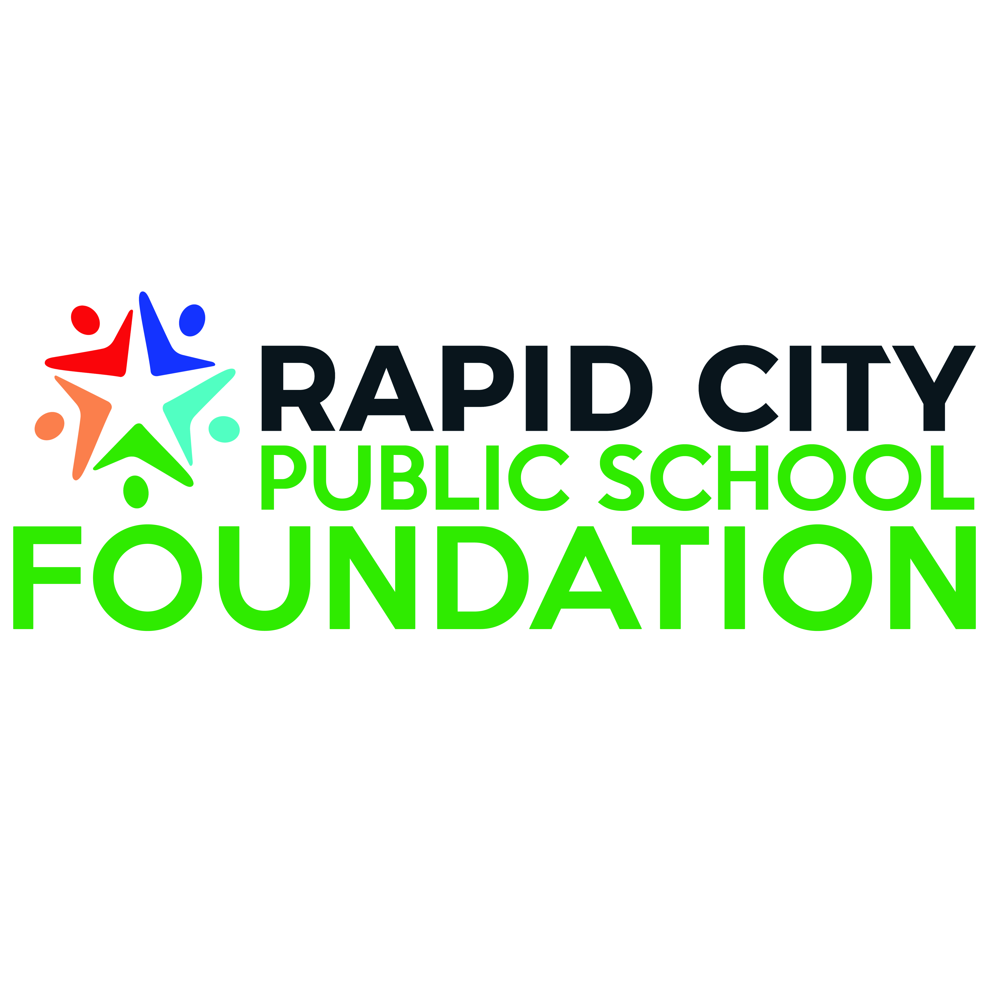
GRANT PROGRAM - APPLICATION
Complete the application below and send it to Laura Sobczak: Laura.Sobczak@k12.sd.us. For more information, please see grant guidelines document, located at www.rcpsfoundation.org.

Grants are awarded twice a year. Deadlines for consideration are November 1 and April 1. Awarded funds should be available by December 15 and May 15 respectively.

If you have any questions about the application or the process, please contact Laura Sobczak (605-390-0131).

Please select the type and category of grant application:
Type | Category
- Small Grant (Limit of $2,000)  - Large Grant ($2,000+, maximum amount at the discretion of the grants committee) | - Grade Level Reading Proficiency by the end of 3rd grade  - 21st Century Learning  - Innovative Teaching and Leadership/Professional Development  - College and Career Readiness  - School-Community Partnerships  - Need-Based Student Development  - Innovative Initiatives
Applicant’s Name
School
Grade Level/Subject
Title of Grant Proposal
Grant Proposal summary
(100 words or less that clearly state existing need, grant goals (or big ideas) and how the proposal will address student learning.)
Date submitted
Amount requested
Grant Deadline Date  (select one) | November 1 or April 1

Problem Statement or … “Why do you need this grant?”
This describes why the funds are needed.
Problem Statement:

Project Design or …“What does your proposal include?”
This section includes outcomes or objectives, action steps, a timeline and how many students will be included in this project.
Objectives or …“What do you want the students to KNOW and/or BE ABLE TO DO ? “
(Objectives are written for the student and they state what the student is expected to know or do as a result of the action/instruction. Objectives are specific, observable and measurable learning outcomes. Please list objectives.

Action Steps or… “How will the project proceed, step by step?”

Timeline or … “When will the project start and what is timeframe for the completion?”

Number of Students or … “How many students will meaningfully be impacted by this project?”

Budget or… “What do you need and what will it cost?
In the table below, please list what resources you will need, the cost and where you suggest they should be purchased.

Resources Needed | Cost | Purchasing Information

Assessment or … “How will you know if student learning was impacted?” How will you assess the impact of this grant on student learning? Describe how you will assess the ‘before and after’ in relation to student learning. Please see website to find assessment questions to be answered in the assessment report (due one month after the project is complete).

Questions
1.Have you requested or received full or supplemental funding from any other source? (Yes or No) ___________________ If so, please explain:

2. If this grant proposal is not fully funded, will the grant writer accept a lesser amount? (Yes or No) _______________________

3. Will this grant be part of matched funding? (Yes or No) __________________
If you answered yes, do you need RCPSF to act as a fiscal sponsor?
(Yes or No) __________________
Please explain.

Grantee Signature: ___________________________________ Date:______________

Principal Signature: ___________________________________ Date:______________

Please forward all completed applications to Laura Sobczak, Executive Director RCPSF, Laura.Sobczak@k12.sd.us.

